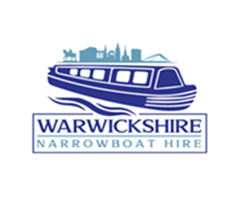
GETTING STARTED ON A CANAL BOAT
So, you’re thinking of taking a canal boat / narrowboat holiday – good for you! It will be an experience you will never forget, and we promise it will be a very unique way to explore new parts of the UK.

Here’s some top tips for your canal boat holiday. You can find out more with the Boating Handbook but here are some essentials you need to know.

Choose your skipper – at least one person needs to know the boat-handling basics, to understand the safety guidelines and to know what to do in an emergency. It’s then his or her job to make sure your crew and passengers have all the information they need to stay safe. It’s a good idea to be clear on each crew member’s duties.
Good boating takes teamwork. So you need competent crew who know how to handle the boat and how to stop the engine, and who can help with mooring, moving through locks, navigation and so on.
Make sure you and your crew know how to handle the narrow boat – and that you know how to handle it on the waterway you’re using
Get local information from the navigation authority before going onto unfamiliar waterways. On rivers, get information on stream conditions and any tides
Plan your cruise and allow enough time to complete it without rushing
Do not cruise in the dark or when visibility’s bad
Make sure you’ve got full tanks of water and fuel

