KEEPING SAFE ON THE WATER
You’re enjoying your holiday, getting the hang of the locks and steering the boats, so don’t ruin it by having an accident!

What causes falls?

Trips over ropes, mooring stakes and so on – especially when left untidy
Walking on narrow decks on boats that tend to rock
Jumping off or stepping off in a dangerous place
Slipping on a wet deck
Moving about the boat or waterside at night
Too much to drink

Safety essentials
Watch out for collisions – and if you are going to bump, warn your crew and passengers
Always use the grab rail
Keep your boat tidy
Don’t jump off the boat when mooring
Wear non-slip deck-shoes
Take extra care on towpaths at night. Always use a torch
Don’t leave the helm when the engine’s running. If someone falls into the water, they could be injured by the moving propeller. And don’t leave the keys in the ignition unattended. Never run the propeller when the boat’s moored up.

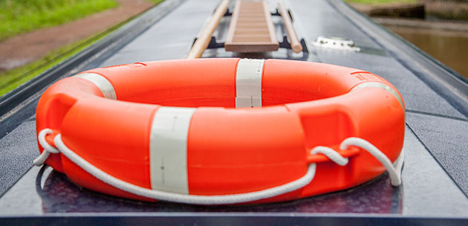

Should I wear a lifejacket?
Children, non-swimmers and lone boaters should wear lifejackets whenever they’re on deck. And that applies to everyone if you’re negotiating tidal waters, strong streams or currents or if the decks are slippery and whenever the water is likely to be cold.

Of course, it’s always safer to wear a lifejacket or buoyancy garment – but check conditions and use your judgement.

Avoiding accidents
Man overboard

Before you do anything else, take a breath and think. Don’t panic, don’t jump in – and don’t let others jump in. The water is very cold even in summer. Keep sight of the person in the water at all times.

Turn your engine off. Don’t reverse the boat – the person in the water could be dragged into the propeller. Throw a line or a lifebelt and tell them to try to stand up – if it’s a canal they might be able to walk out.

Steer the boat slowly to the bank and get one of your passengers to help the person to shore. On wider or deeper waterways Throw a lifebuoy or line and steer your boat carefully to approach the person in the water. Keep a constant watch to ensure your propeller is well away from them. Stop the propeller immediately by selecting neutral gear if there’s a risk of them getting close to it.

Pull them to the side of the boat and help them aboard with a ladder, rope or pole.

Be prepared
Make sure everyone on the boat knows the drill – and knows where to find the lifeline or lifebelt. In case it’s the skipper who falls overboard, the crew should also know how to stop the propeller and steer the boat. Practice the drill. It’s better to learn it before an accident happens.

