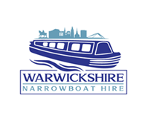MOORING UP
I’ve travelled down the canal on my Narrowboat, now I want to moor up. Where am I allowed to stop to moor a boat?

Stop short of where you want to moor with your boat straight and in deep water. Move forward very slowly, pointing the front of the boat towards the bank, then use reverse to stop the boat just before the front hits the bank. Put the engine into neutral.

On rivers, you should always moor with the front of your boat facing upstream or into a very strong wind. So, if you’re heading downstream, you’ll need to pass the mooring and turn your boat around. Allow for the fact that the water level may rise or fall by several feet. If it’s a tidal river, you should always moor facing the tide – and avoid mooring to the bank overnight.

Your crew should step ashore – not jump. They can either carry the ropes with them – making sure there’s plenty of slack and that one end is fixed to the boat – or you can pass them the ropes once they’re on land.

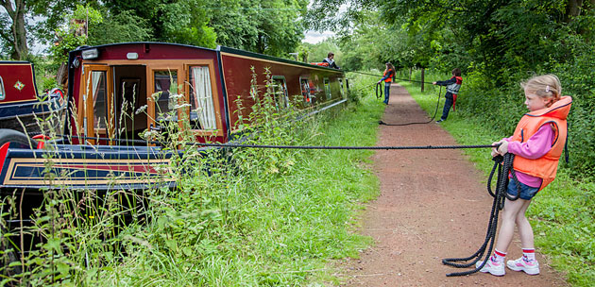

Tying up
To keep your boat secure, you need to tie it to the bank with a rope from both the front and the back. On rivers, you should fix your upstream rope first.

Many mooring sites have bollards or rings to tie up to – choose ones a short distance beyond the front and the back of your boat. Run your ropes at about 45º from your boat, loop them back onto the boat and tie securely, but not too tightly.
To stop your boat moving backwards and forwards in flowing water, you can use ‘springs’ – see example below right. If there aren’t any bollards or rings, use your mooring stakes, but check the stability of the bank and watch out for signs of underground pipes or cables before you start hammering. Knock them in to about three-quarters their length and make sure they’re firm. Mark them with a piece of light-coloured cloth or a white carrier bag so that other towpath users can see them clearly, and don’t tie your ropes across the towpath.
Leave a little slack in your ropes – that’s especially important on tidal waterways or rivers. If the ropes are too tight and the water level drops, your boat could be left hanging from the bank.
Remember that your anchor should be used if you need added security or extra help in a strong stream or tide – and you should still use mooring ropes.
Can I moor here?
Use signposted visitor moorings wherever possible, and always moor to the towpath if you can. Check that you’re not a hazard to other boats or to people using the bank. Leave room for other boats to tie up too. Use authorised sites on rivers. Many riverbanks and the non towpath side of canals are private property.
Don’t moor:
*In lock approaches or in lock flights
*Near swing or lift bridges
*Near weirs
*Near sharp bends
*By blind spots
*In or opposite turning points
*At junctions
*To the bank on a tidal river – you might find yourself hanging from the ropes when the tide goes out!
*In stretches marked out for an angling match
*And try to stay 50 feet (15m) away from established angling spots.

